**P**ROMO

**E**XECUTION

**R**EPORT

By :**FELJUN BUENO**

Before you can enter the program a SECURITY CHECK will appear to verify your user name and password.

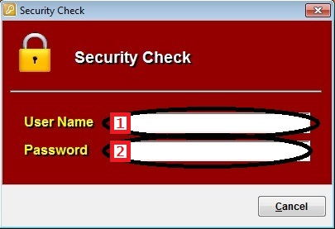

**Stock Withdrawal Advice**

1. To enter stock withdrawal advice form, from the main menu click on STOCK WITHDRAWAL ADVICE > STOCK WITHDRAWAL ADVICE.

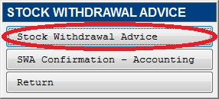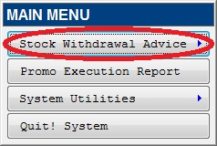

1. To open an existing SWA form, click OPEN button.

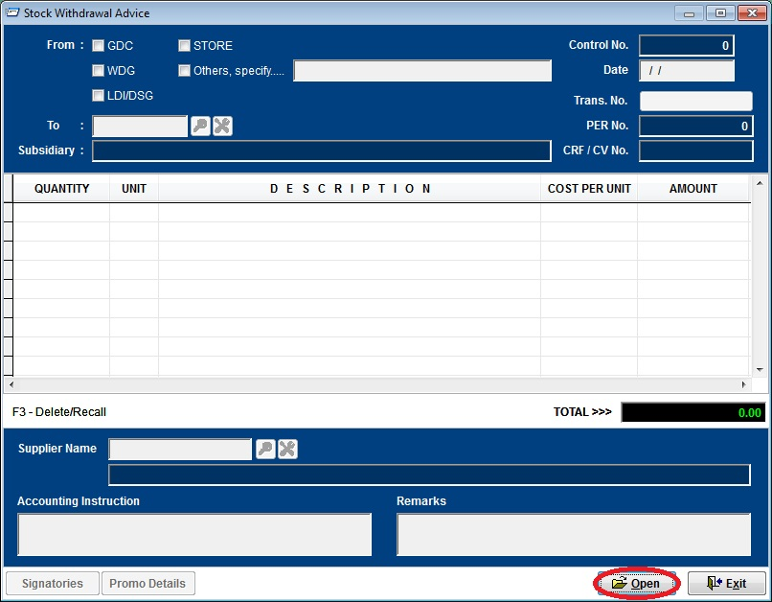

1. Select previous SWA entries. Then click the CHECK button to select.

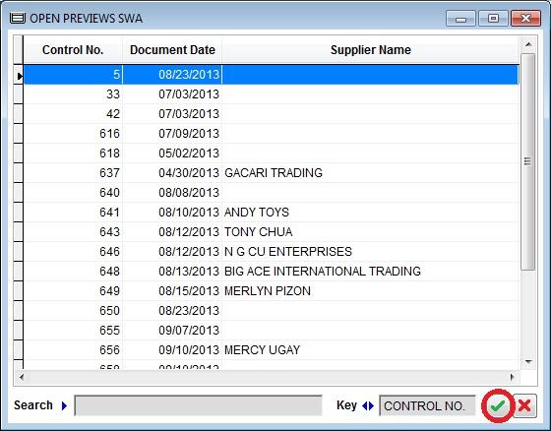

1. To enter promo execution report, from the main menu click on PROMO EXECUTION REPORT.

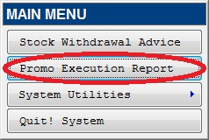

* 1. To create Promo Execution Report.
     1. Click NEW button
     2. Type current date
     3. Enter the SWA Series number to retrieve an existing SWA file
     4. Enter the actual execution quantity and the un-used quantity allocated
     5. Type the execution summary
     6. Type post promo remarks

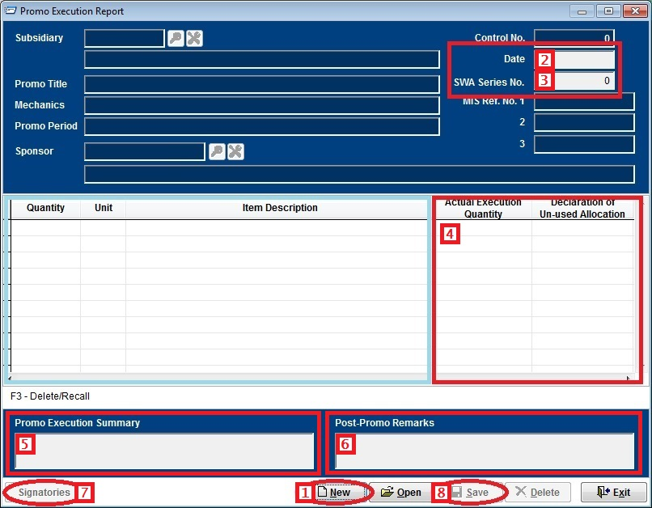

* + 1. For the signatories, click on the SIGNATORIES button

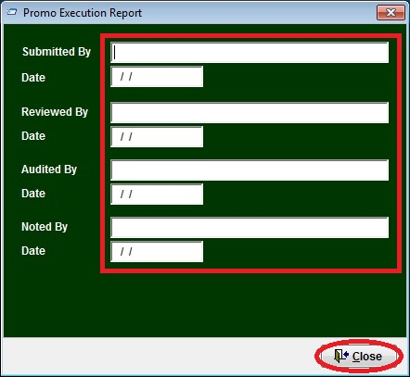

* + 1. Next is to save and print the PER form. Just click on the SAVE button, then follow the steps bellow.

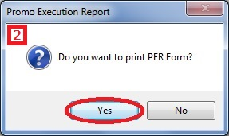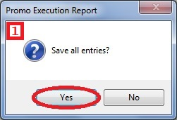

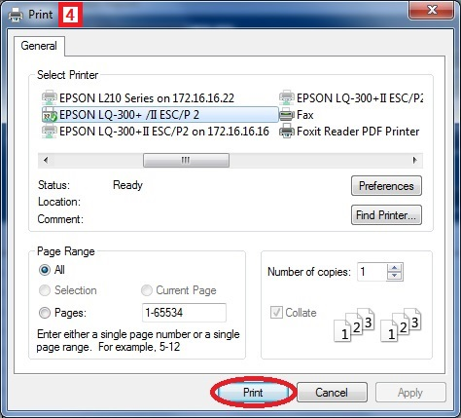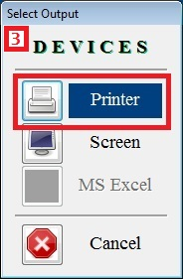

**System Utilities**

1. To change the wallpaper, from the main menu select SYSTEM UTILITIES > SYSTEM WALLPAPER.

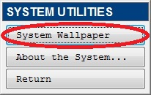

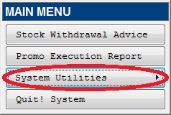

1. Click BROWSE button to select a picture you want to be the wallpaper in your screen.

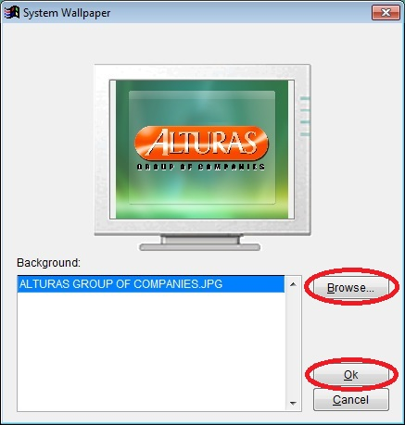

1. Then click OK button to accept picture.

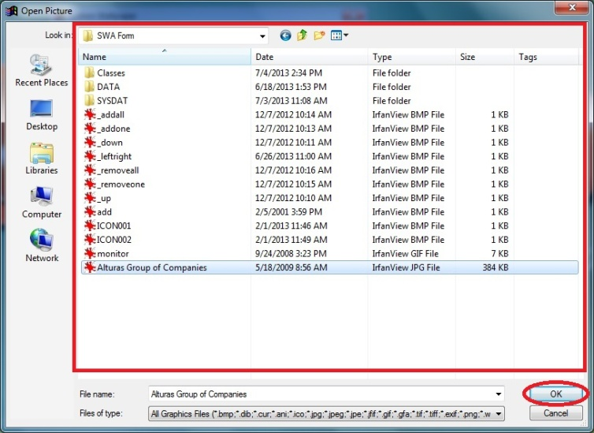

1. Then press OK again in the Wallpaper window to apply the picture as the system wallpaper.
2. To view the system information, from the main menu select SYSTEM UTILITIES > ABOUT THE SYSTEM....

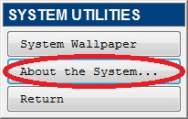

1. About the stock withdrawal advice monitoring system.

